The Absolutely True Diary of a Part-Time Indian

The Absolutely True Diary of a Part-Time Indian
The story revolves around Arnold "Junior" Spirit, a 14-year-old boy who lives on the Spokane Indian Reservation in Washington state. Born with physical disabilities and growing up in poverty, Junior faces numerous challenges and is often an outcast within his community.
Despite his circumstances, Junior is determined to rise above the limitations placed on him and seek a better life. He makes a bold decision to transfer to the all-white high school in the nearby town, leaving behind his friends and family on the reservation. This decision is met with a mix of support and backlash from his community, leading to conflicts and difficult choices.

Elements to Consider While Reading

Predicting
Before you read a story, you make guesses or predictions about what will happen based on the title and what you know of the author. You continue to make predictions about what will happen next and how the story will end. You should base your predictions on:
- what you already know about the characters
- what has already happened in the story
- what you know about people from your own experience
- the plots of other stories you have read

Point of View
Point of View | Story Text | Who’s Telling the Story
first-person | “I was getting fed up with saying goodbye. One month five kids disappeared from my shrinking class of Copelin High School.” (from The Visitor by Christine Pinsent-Johnson) | a character from the story
third-person limited | Willy felt like he was spending his whole life saying goodbye. It seemed like every other day one more person left his class at Copelin High School. (adapted from The Visitor) | a narrator who knows the thoughts of only one story character
Third-person omniscient | Copelin was a dying community. Moving vans and red-and-white U-haul trailers were a weekly sight on its pot-holed streets. (adapted from The Visitor) | a narrator who knows everything

Setting
The time and location in which a story takes place is called the setting. In some stories the setting is very important, but in other stories it is hardly mentioned. As you read a story or novel, ask yourself these questions about the setting:
- What does the author tell your about the place where the story happens?
- Are the characters in conflict with the setting?
- What does the setting tell you about the characters?
- How does the setting contribute to the atmosphere or mood of the story?

Characters
Ask yourself:
- Who are the main characters in the story? Who are the minor characters?
- Which of the characters do you identify with most?
- Do any of the characters remind you of people you know?
- Is the story told from the point of view of one or more of the characters?
- What events are the characters involved in?

Character Types
Round Characters: Characters who display several personality traits (like real people.)
Static Characters: these are characters who stay the same.
Stereotype Characters: Characters who behave in a predictable way. These characters all behave in the same way, they aren’t individuals. For example: the “jock,” the “nerd.”

Determining Character Traits
The writer establishes character, or personality, through words and actions. A successful writer will cause the reader to understand characters’ feelings in various situations. A character’s responses to conflicting situations, such as anger in one scene and tolerance in another, require the reader to determine which trait dominates within a person. A single action does not determine a trait, but it adds to an impression of a certain trait.
Identifying trait is often difficult. General descriptions such as “He cannot wait to obtain all the facts before he does something he later regrets” are not traits. A precise word is needed. “He is impulsive” identifies the trait that must be supported with details later. Because you are expanding your vocabulary continuously, the following word bank may be helpful.
Words to Describe Character Traits
abrupt | determined | indecisive | responsible
adaptable | dishonest | inflexible | sarcastic
affectionate | domineering | insecure | secretive
aggressive | eccentric | judgemental | self-conscious
ambitious | energetic | just | selfish
anxious | enthusiastic | loyal | sensitive
arrogant | fair | meek | shrewd
artistic | fickle | methodical | sly
blunt | foolhardy | modest | sophisticated
boastful | forgiving | moody | spontaneous
cautious | frustrated | nervous | stubborn
competent | generous | obstinate | superficial
conceited | gentle | open-minded | tactful
courageous | gloomy | outgoing | timid
creative | happy | outrageous | truthful
critical | helpful | patient | uncertain
cruel | humble | persistent | uninhibited
cunning | imaginative | proud | unpredictable
curious | impatient | quarrelsome | weak
decisive | impetuous | resourceful | wise
dependable | impolite | respectful

Conflict
Conflict is the basis of every story. Conflict occurs when characters experience problems. We keep reading because we want to find out how the problems will be solved. Conflict can be serious, or light-hearted and humorous.
There are two basic kinds of conflict in literature: external conflict and internal conflict.
External conflict is the struggle between a character and something outside of him or her for example:
- Nature: weather/landscape/animals
- People: family/friends/strangers
- Situations: war/poverty/unemployment
Internal conflict is a struggle that takes place with a person. This struggle usually involves making choices:
- Between good and evil
- Between self-interest and helping others

Symbols
A symbol is an object, an animal, or a person that suggests something else, such as an idea or a belief. For example: a crown is a symbol for a monarch, a dove is a symbol for peace, a police officer is a symbol of law and order.
Recognizing symbols will help you understand the literature you read.
Symbols are usually:
- visual
- repeated several times
- related to the theme of the selection

Context Clues
Context Clues: Context clues are hints to meaning from other words or phrases in the sentence.
The following examples demonstrate context clues in action.
- I was a fragile child, often sick and small for my age. My grandmother always called me feeble.
You guess from the narrator's description of himself - “sick”, “small” - that feeble means weak.
- I didn’t want to popsicle anymore so I discarded it in the garbage can.
You know from the speaker’s comments about the popsicle that he does not want it anymore, so you can conclude that discard means to throw away.
- Colour is inconceivable to someone born blind.
A blind person cannot imagine colour if it has never been in his visual experience; therefore, inconceivable means impossible to imagine.
Make sure to access the assignment prior to starting to read your novel so you do not miss any pre-reading questions.
(this link opens in a new window/tab)

Speak

Speak
The story follows the life of Melinda Sordino, a high school freshman who becomes an outcast after she calls the police during a summer party. The incident isn't immediately explained, but as the story unfolds, it becomes clear that something traumatic happened to Melinda at the party. She finds herself unable to speak about it, leading to a significant communication breakdown between her and those around her, including her friends, family, and teachers.
"Speak" addresses difficult subject matter such as sexual assault and its aftermath in a sensitive and thought-provoking manner. The novel delves into the psychological and emotional impact of trauma, as well as the complex process of healing and recovery.

Elements to Consider While Reading
The following elements are important to review and consider to help with the analysis of what you read in the novel.

Predicting
Before you read a story, you make guesses or predictions about what will happen based on the title and what you know of the author. You continue to make predictions about what will happen next and how the story will end. You should base your predictions on:
- what you already know about the characters
- what has already happened in the story
- what you know about people from your own experience
- the plots of other stories you have read

Point of View
Point of View | Story Text | Who’s Telling the Story
first-person | “I was getting fed up with saying goodbye. One month five kids disappeared from my shrinking class of Copelin High School.” (from The Visitor by Christine Pinsent-Johnson) | a character from the story
third-person limited | Willy felt like he was spending his whole life saying goodbye. It seemed like every other day one more person left his class at Copelin High School. (adapted from The Visitor) | a narrator who knows the thoughts of only one story character
Third-person omniscient | Copelin was a dying community. Moving vans and red-and-white U-haul trailers were a weekly sight on its pot-holed streets. (adapted from The Visitor) | a narrator who knows everything

Setting
The time and location in which a story takes place is called the setting. In some stories the setting is very important, but in other stories it is hardly mentioned. As you read a story or novel, ask yourself these questions about the setting:
- What does the author tell your about the place where the story happens?
- Are the characters in conflict with the setting?
- What does the setting tell you about the characters?
- How does the setting contribute to the atmosphere or mood of the story?

Characters
Ask yourself:
- Who are the main characters in the story? Who are the minor characters?
- Which of the characters do you identify with most?
- Do any of the characters remind you of people you know?
- Is the story told from the point of view of one or more of the characters?
- What events are the characters involved in?

Character Types
Round Characters: Characters who display several personality traits (like real people.)
Static Characters: these are characters who stay the same.
Stereotype Characters: Characters who behave in a predictable way. These characters all behave in the same way, they aren’t individuals. For example: the “jock,” the “nerd.”

Determining Character Traits
The writer establishes character, or personality, through words and actions. A successful writer will cause the reader to understand characters’ feelings in various situations. A character’s responses to conflicting situations, such as anger in one scene and tolerance in another, require the reader to determine which trait dominates within a person. A single action does not determine a trait, but it adds to an impression of a certain trait.
Identifying trait is often difficult. General descriptions such as “He cannot wait to obtain all the facts before he does something he later regrets” are not traits. A precise word is needed. “He is impulsive” identifies the trait that must be supported with details later. Because you are expanding your vocabulary continuously, the following word bank may be helpful.
Words to Describe Character Traits
abrupt | determined | indecisive | responsible
adaptable | dishonest | inflexible | sarcastic
affectionate | domineering | insecure | secretive
aggressive | eccentric | judgemental | self-conscious
ambitious | energetic | just | selfish
anxious | enthusiastic | loyal | sensitive
arrogant | fair | meek | shrewd
artistic | fickle | methodical | sly
blunt | foolhardy | modest | sophisticated
boastful | forgiving | moody | spontaneous
cautious | frustrated | nervous | stubborn
competent | generous | obstinate | superficial
conceited | gentle | open-minded | tactful
courageous | gloomy | outgoing | timid
creative | happy | outrageous | truthful
critical | helpful | patient | uncertain
cruel | humble | persistent | uninhibited
cunning | imaginative | proud | unpredictable
curious | impatient | quarrelsome | weak
decisive | impetuous | resourceful | wise
dependable | impolite | respectful

Conflict
Conflict is the basis of every story. Conflict occurs when characters experience problems. We keep reading because we want to find out how the problems will be solved. Conflict can be serious, or light-hearted and humorous.
There are two basic kinds of conflict in literature: external conflict and internal conflict.
External conflict is the struggle between a character and something outside of him or her for example:
- Nature: weather/landscape/animals
- People: family/friends/strangers
- Situations: war/poverty/unemployment
Internal conflict is a struggle that takes place with a person. This struggle usually involves making choices:
- Between good and evil
- Between self-interest and helping others

Symbols
A symbol is an object, an animal, or a person that suggests something else, such as an idea or a belief. For example: a crown is a symbol for a monarch, a dove is a symbol for peace, a police officer is a symbol of law and order.
Recognizing symbols will help you understand the literature you read.
Symbols are usually:
- visual
- repeated several times
- related to the theme of the selection

Context Clues
Context Clues: Context clues are hints to meaning from other words or phrases in the sentence.
The following examples demonstrate context clues in action.
- I was a fragile child, often sick and small for my age. My grandmother always called me feeble.
You guess from the narrator's description of himself - “sick”, “small” - that feeble means weak.
- I didn’t want to popsicle anymore so I discarded it in the garbage can.
You know from the speaker’s comments about the popsicle that he does not want it anymore, so you can conclude that discard means to throw away.
- Colour is inconceivable to someone born blind.
A blind person cannot imagine colour if it has never been in his visual experience; therefore, inconceivable means impossible to imagine.

Make sure to access the assignment prior to starting to read your novel so you do not miss any pre-reading questions.
(this link opens in a new window/tab)

Deathwatch

Deathwatch
In this section, you will read and study the novel Deathwatch, a fast-moving story about a life-and-death struggle between two men. It is also a story in which the setting plays a major role in the development of the conflict.
The emphasis in this section is on reading for interpretation and application to daily life. You will be writing journal entries about your reaction to characters and events in the novel, and you will be encouraged to connect incidents in the story to your views and experiences.
Background
In any novel, you generally find more characters, more settings, and a more complicated plot than in a short story in which these elements must be compressed because of length. The novelist has the opportunity to show everything in more detail. In Deathwatch, the author’s use of detail creates two strong characters, an interesting conflict, and a vivid-setting. The details make the story believable to the reader. Once you believe in a story, you cannot help but get “hooked” by it.
The author, Robb White, was born in the Philippines, the son of a missionary. After leaving school, he spent some time in the navy. Later, his series of adventurous experiences in various countries have him background material for many short stories and novels.
Deathwatch is set in the United States in a desert area near mountains. The exact location is not revealed, but there are hints that Edwards Air Force base is in the region. Thus, you can conclude that the story takes place in the Mojave Desert region of southeastern California. The Mojave (Moh-Hah-Vee) Desert is the darker colour on the map below.
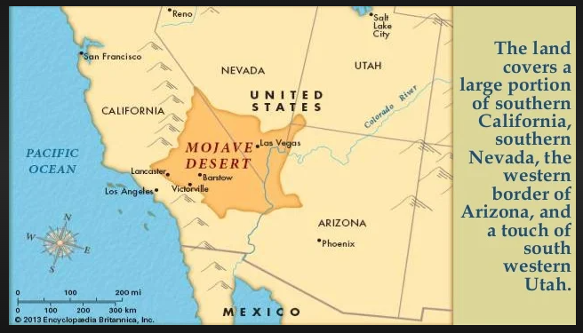
The map below gives a more detail of the setting:
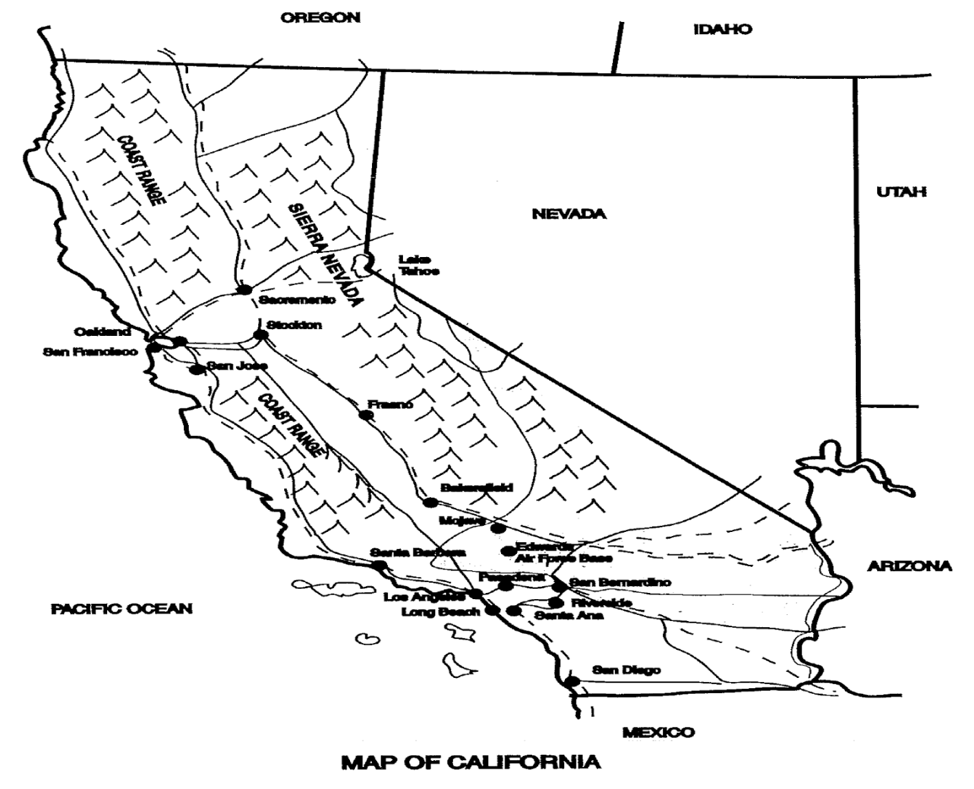
In reading this novel, you will need to know the following information about guns. One of the characters, Madec, is a trophy hunter - someone who hunts to show off the skin or head of a prize animal. He uses a rifle called a .358. The number, .358, indicates bullet width or barrel size. A .358 rifle is a very powerful weapon. The other character, Ben, carries a .22 calibre Hornet, which is small in power and no match for a .358.
Because the action is set in California, you may be unfamiliar with some of the jargon, or technical language, used throughout the novel. Use a dictionary to provide definitions for the list of unusual words in your assignment before you begin to read the novel. Refer to your completed vocabulary log as you read the novel.

Elements to Consider While Reading

Predicting
Before you read a story, you make guesses or predictions about what will happen based on the title and what you know of the author. You continue to make predictions about what will happen next and how the story will end. You should base your predictions on:
- what you already know about the characters
- what has already happened in the story
- what you know about people from your own experience
- the plots of other stories you have read

Point of View
Point of View | Story Text | Who’s Telling the Story
first-person | “I was getting fed up with saying goodbye. One month five kids disappeared from my shrinking class of Copelin High School.” (from The Visitor by Christine Pinsent-Johnson) | a character from the story
third-person limited | Willy felt like he was spending his whole life saying goodbye. It seemed like every other day one more person left his class at Copelin High School. (adapted from The Visitor) | a narrator who knows the thoughts of only one story character
Third-person omniscient | Copelin was a dying community. Moving vans and red-and-white U-haul trailers were a weekly sight on its pot-holed streets. (adapted from The Visitor) | a narrator who knows everything

Setting
The time and location in which a story takes place is called the setting. In some stories the setting is very important, but in other stories it is hardly mentioned. As you read a story or novel, ask yourself these questions about the setting:
- What does the author tell your about the place where the story happens?
- Are the characters in conflict with the setting?
- What does the setting tell you about the characters?
- How does the setting contribute to the atmosphere or mood of the story?

Deathwatch Typography
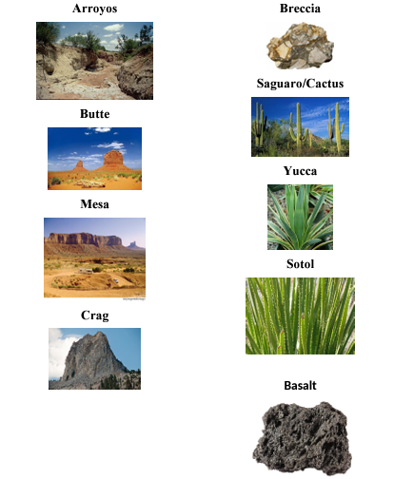

Characters
Ask yourself:
- Who are the main characters in the story? Who are the minor characters?
- Which of the characters do you identify with most?
- Do any of the characters remind you of people you know?
- Is the story told from the point of view of one or more of the characters?
- What events are the characters involved in?

Character Types
Round Characters: Characters who display several personality traits (like real people.)
Static Characters: these are characters who stay the same.
Stereotype Characters: Characters who behave in a predictable way. These characters all behave in the same way, they aren’t individuals. For example: the “jock,” the “nerd.”

Determining Character Traits
The writer establishes character, or personality, through words and actions. A successful writer will cause the reader to understand characters’ feelings in various situations. A character’s responses to conflicting situations, such as anger in one scene and tolerance in another, require the reader to determine which trait dominates within a person. A single action does not determine a trait, but it adds to an impression of a certain trait.
Identifying trait is often difficult. General descriptions such as “He cannot wait to obtain all the facts before he does something he later regrets” are not traits. A precise word is needed. “He is impulsive” identifies the trait that must be supported with details later. Because you are expanding your vocabulary continuously, the following word bank may be helpful.
Words to Describe Character Traits
abrupt | determined | indecisive | responsible
adaptable | dishonest | inflexible | sarcastic
affectionate | domineering | insecure | secretive
aggressive | eccentric | judgemental | self-conscious
ambitious | energetic | just | selfish
anxious | enthusiastic | loyal | sensitive
arrogant | fair | meek | shrewd
artistic | fickle | methodical | sly
blunt | foolhardy | modest | sophisticated
boastful | forgiving | moody | spontaneous
cautious | frustrated | nervous | stubborn
competent | generous | obstinate | superficial
conceited | gentle | open-minded | tactful
courageous | gloomy | outgoing | timid
creative | happy | outrageous | truthful
critical | helpful | patient | uncertain
cruel | humble | persistent | uninhibited
cunning | imaginative | proud | unpredictable
curious | impatient | quarrelsome | weak
decisive | impetuous | resourceful | wise
dependable | impolite | respectful

Conflict
Conflict is the basis of every story. Conflict occurs when characters experience problems. We keep reading because we want to find out how the problems will be solved. Conflict can be serious, or light-hearted and humorous.
There are two basic kinds of conflict in literature: external conflict and internal conflict.
External conflict is the struggle between a character and something outside of him or her for example:
- Nature: weather/landscape/animals
- People: family/friends/strangers
- Situations: war/poverty/unemployment
Internal conflict is a struggle that takes place with a person. This struggle usually involves making choices:
- Between good and evil
- Between self-interest and helping others

Symbols
A symbol is an object, an animal, or a person that suggests something else, such as an idea or a belief. For example: a crown is a symbol for a monarch, a dove is a symbol for peace, a police officer is a symbol of law and order.
Recognizing symbols will help you understand the literature you read.
Symbols are usually:
- visual
- repeated several times
- related to the theme of the selection

Context Clues
Context Clues: Context clues are hints to meaning from other words or phrases in the sentence.
The following examples demonstrate context clues in action.
- I was a fragile child, often sick and small for my age. My grandmother always called me feeble.
You guess from the narrator's description of himself - “sick”, “small” - that feeble means weak.
- I didn’t want to popsicle anymore so I discarded it in the garbage can.
You know from the speaker’s comments about the popsicle that he does not want it anymore, so you can conclude that discard means to throw away.
- Colour is inconceivable to someone born blind.
A blind person cannot imagine colour if it has never been in his visual experience; therefore, inconceivable means impossible to imagine.

Make sure to access the assignment prior to starting to read your novel so you do not miss any pre-reading questions.
(this link opens in a new window/tab)

Lion (A Long Way Home)

Lion (A Long Way Home)
Can you imagine being lost and not finding your way home again? Saroo Brierley got lost on a train in India at the age of five. Not knowing the name of his family ow where he was from, he survived for weeks on the streets in Kolkata, before being taken into an orphanage and adopted by a family from Australia.
Despite being happy in his new home, Saroo always wondered about his origins. He spent hours staring at the map of India on his bedroom wall. He poured over satellite images on Google Earth seeking out landmarks he recognized. And one day, after years of searching, he miraculously found what he was looking for.
Then he set off on a journey back to India to see if he could find his mother.

Elements to Consider While Reading
The following elements are important to review and consider to help with the analysis of what you read in the novel.

Predicting
Before you read a story, you make guesses or predictions about what will happen based on the title and what you know of the author. You continue to make predictions about what will happen next and how the story will end. You should base your predictions on:
- what you already know about the characters
- what has already happened in the story
- what you know about people from your own experience
- the plots of other stories you have read

Point of View
Point of View | Story Text | Who’s Telling the Story
first-person | “I was getting fed up with saying goodbye. One month five kids disappeared from my shrinking class of Copelin High School.” (from The Visitor by Christine Pinsent-Johnson) | a character from the story
third-person limited | Willy felt like he was spending his whole life saying goodbye. It seemed like every other day one more person left his class at Copelin High School. (adapted from The Visitor) | a narrator who knows the thoughts of only one story character
Third-person omniscient | Copelin was a dying community. Moving vans and red-and-white U-haul trailers were a weekly sight on its pot-holed streets. (adapted from The Visitor) | a narrator who knows everything

Setting
The time and location in which a story takes place is called the setting. In some stories the setting is very important, but in other stories it is hardly mentioned. As you read a story or novel, ask yourself these questions about the setting:
- What does the author tell your about the place where the story happens?
- Are the characters in conflict with the setting?
- What does the setting tell you about the characters?
- How does the setting contribute to the atmosphere or mood of the story?

Characters
Ask yourself:
- Who are the main characters in the story? Who are the minor characters?
- Which of the characters do you identify with most?
- Do any of the characters remind you of people you know?
- Is the story told from the point of view of one or more of the characters?
- What events are the characters involved in?

Character Types
Round Characters: Characters who display several personality traits (like real people.)
Static Characters: these are characters who stay the same.
Stereotype Characters: Characters who behave in a predictable way. These characters all behave in the same way, they aren’t individuals. For example: the “jock,” the “nerd.”

Determining Character Traits
The writer establishes character, or personality, through words and actions. A successful writer will cause the reader to understand characters’ feelings in various situations. A character’s responses to conflicting situations, such as anger in one scene and tolerance in another, require the reader to determine which trait dominates within a person. A single action does not determine a trait, but it adds to an impression of a certain trait.
Identifying trait is often difficult. General descriptions such as “He cannot wait to obtain all the facts before he does something he later regrets” are not traits. A precise word is needed. “He is impulsive” identifies the trait that must be supported with details later. Because you are expanding your vocabulary continuously, the following word bank may be helpful.
Words to Describe Character Traits
abrupt | determined | indecisive | responsible
adaptable | dishonest | inflexible | sarcastic
affectionate | domineering | insecure | secretive
aggressive | eccentric | judgemental | self-conscious
ambitious | energetic | just | selfish
anxious | enthusiastic | loyal | sensitive
arrogant | fair | meek | shrewd
artistic | fickle | methodical | sly
blunt | foolhardy | modest | sophisticated
boastful | forgiving | moody | spontaneous
cautious | frustrated | nervous | stubborn
competent | generous | obstinate | superficial
conceited | gentle | open-minded | tactful
courageous | gloomy | outgoing | timid
creative | happy | outrageous | truthful
critical | helpful | patient | uncertain
cruel | humble | persistent | uninhibited
cunning | imaginative | proud | unpredictable
curious | impatient | quarrelsome | weak
decisive | impetuous | resourceful | wise
dependable | impolite | respectful

Conflict
Conflict is the basis of every story. Conflict occurs when characters experience problems. We keep reading because we want to find out how the problems will be solved. Conflict can be serious, or light-hearted and humorous.
There are two basic kinds of conflict in literature: external conflict and internal conflict.
External conflict is the struggle between a character and something outside of him or her for example:
- Nature: weather/landscape/animals
- People: family/friends/strangers
- Situations: war/poverty/unemployment
Internal conflict is a struggle that takes place with a person. This struggle usually involves making choices:
- Between good and evil
- Between self-interest and helping others

Symbols
A symbol is an object, an animal, or a person that suggests something else, such as an idea or a belief. For example: a crown is a symbol for a monarch, a dove is a symbol for peace, a police officer is a symbol of law and order.
Recognizing symbols will help you understand the literature you read.
Symbols are usually:
- visual
- repeated several times
- related to the theme of the selection

Context Clues
Context Clues: Context clues are hints to meaning from other words or phrases in the sentence.
The following examples demonstrate context clues in action.
- I was a fragile child, often sick and small for my age. My grandmother always called me feeble.
You guess from the narrator's description of himself - “sick”, “small” - that feeble means weak.
- I didn’t want to popsicle anymore so I discarded it in the garbage can.
You know from the speaker’s comments about the popsicle that he does not want it anymore, so you can conclude that discard means to throw away.
- Colour is inconceivable to someone born blind.
A blind person cannot imagine colour if it has never been in his visual experience; therefore, inconceivable means impossible to imagine.

Make sure to access the assignment prior to starting to read your novel so you do not miss any pre-reading questions.

How to Write a Literary Exploration Essay
First, consider how your essay should be structured. The anchor chart below lays out the key characteristics of each paragraph you want to include in your essay:
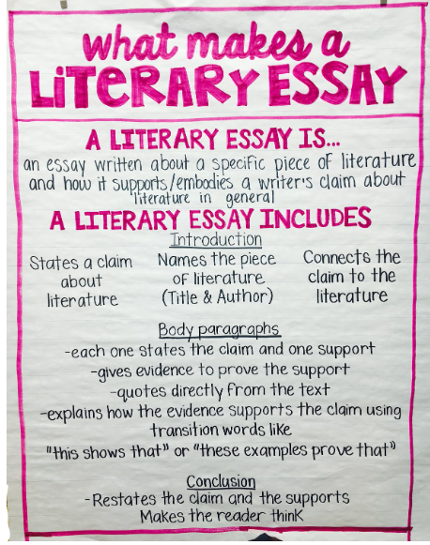

Planning a Literary Exploration Essay About the Novel You Read
Your literary exploration essay should follow the suggested format below:

Format of a Literary Exploration Essay

Introduction
- make some general comments about the topic
- include the name of the book you will be discussing and the author
- make sure you have a thesis (this is the main argument, or claim that you are making) that answers the question being asked.

"What is your opinion of the idea that our choices influence the direction of our life?"

Body Paragraph #1
Discuss the first character that you are using to support your argument (your thesis). Remember to choose details that support the argument and quote the text where you can.

Body Paragraph #2
Discuss a second character from your novel that provides support for your thesis - alternatively this character could be in contrast to your thesis if there is not another character that supports your thesis. Remember to choose details that support your argument.

Body Paragraph #3
Reflect upon your own knowledge and/or experience that supports your thesis. Make sure to choose details that support your argument and show your understanding of how the characters you have chosen are similar - how are you connecting your experiences with what the characters have gone through?

Conclusion
This is your ending where you sum up your ideas and arguments. This allows you to check to make sure that you have answered your thesis.

This template can be used to plan out the literary exploration essay you will write based on the novel you studied.
(this link opens in a new window/tab)

Conclusion

You have now completed the lessons for your novel study.

Next Steps
- Take a moment to plan out which characters you will write about and what evidence from the novel will support your thinking (create an outline).
- Once you have your outline completed, check in with your teacher before writing your literary exploration (the literary exploration needs to be completed at the school).
- Submit your assignment, outline, and literary exploration to your teacher.

